# COMP 10066 Software Quality and Testing Midterm Test – Fall 2023 Test Weight – 25%

**NAME:**

**STUDENT NUMBER:**

## Test Information

Exam Length: 1 hour and 20 minutes

Total Marks: 53 marks

This exam contains 6 pages

This exam has 2 questions in total.

**Please ensure to complete all questions inside this word document.**

If you have any questions or any issues arise please contact your instructor

## Exam Notes

**Turn-it-in will be used to validate the authenticity of your exam.**

## Submission Requirements

* You will submit the following to the Mid-Term Submission Folder on MyCanvas:
  + A **KRecorder file** – the Katalon Recorder Test Suite
  + The exam **WORD document**, with your solutions filled in as required
* KRecorder / WORD Files received by email will NOT be marked
* Please do not submit any ZIP files.

## Question 1 – Black Box Testing and Test Case Planning (27 marks)

You are to plan black box testing for a program that searches for phone extensions in a company. A screen shot of the program is provided below.

DO NOT WORRY ABOUT BOUNDARY TESTING FOR THIS QUESTION.

ASSUME THE PROGRAM CAN HANDLE LARGE STRINGS AND YOU DO NOT HAVE TO TEST IT.

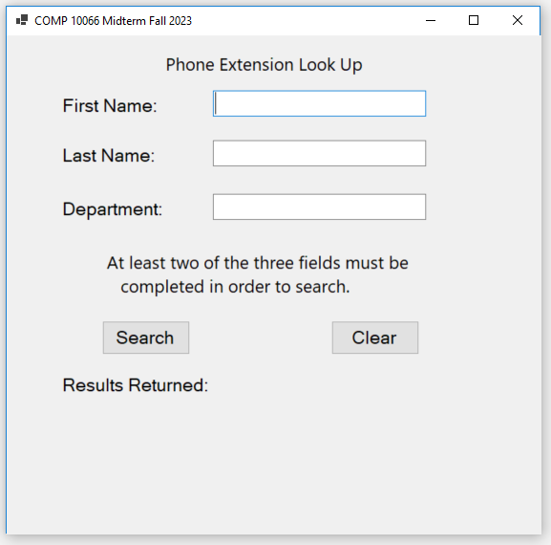

There are 3 inputs and two buttons:

* First Name – A string
* Last Name – A string
* Department – A string
* Search Button – performs the search and displays the possible phone extensions
* Clear Button – Clears both the search results and the three textboxes.

Other Details

* The user must input at least two of the three text boxes before pressing the search button.
* They can enter up to all three pieces of data (first name, last name and department) for a search.
* The result returned is a list of possible employees and their phone extensions

Record your test cases in the table below. You may add more rows as required. Do not add duplicate test cases.

DO NOT WORRY ABOUT BOUNDARY TESTING FOR THIS QUESTION.

ASSUME THE PROGRAM CAN HANDLE LARGE STRINGS AND YOU DO NOT HAVE TO TEST IT.

|  |  |  |  |
| --- | --- | --- | --- |
| Test Case Data | Reason For Test | Expected Result | Test to Pass OR Test to Fail |
| First Name: Gaurav last Name: "Patel", Department: "" | Testing with a valid first and last name, no department | List of employees and their extensions | Test to Pass |
| First Name: "", Last Name: "Patel", Department: "Sales" | Testing with a valid last name and department, no first name | List of employees and their extensions | Test to Pass |
| First Name: " Gaurav ", Last Name: "", Department: "HR | Testing with a valid first name and department, no last name | List of employees and their extensions | Test to Pass |
| First Name: "", Last Name: "Doe", Department: "" | Testing with just a valid last name | List of employees and their extensions | Test to Pass |
| First Name: " Gaurav ", Last Name: " Patel ", Department: "IT" | Testing with all three fields filled | List of employees and their extensions | Test to Pass |
| First Name: "", Last Name: "", Department: "" | Testing with no input in any field | Display an error message | Test to Fail |
| First Name: " Gaurav ", Last Name: "", Department: "" | Testing with only the first name | Display an error message | Test to Fail |
| First Name: "", Last Name: "", Department: "Sales" | Testing with only the department | Display an error message | Test to Fail |
| First Name: "123", Last Name: "456", Department: "789" | Testing with numeric characters in all fields | Display an error message | Test to Fail |
| First Name: " Gaurav ", Last Name: "Patel", Department: "HR&IT" | Testing with special characters in the department name | List of employees and their extensions | Test to Pass |
| First Name: "A B", Last Name: "C D", Department: "E F" | Testing with single letters separated by spa  ces in all fields | List of employees and their extensions | Test to Pass |
| First Name: " ", Last Name: "Doe", Department: "Sales" | Testing with a single space as the first name | Display an error message | Test to Fail |
| First Name: "Jane", Last Name: "Smith", Department: "123" | Testing with numeric characters in the department name | Display an error message | Test to Fail |

## Question 2 – Website Testing, Katalon Recorder, Boundary Testing and Bug Summary (26 marks)

**Part A (20 marks)**

Using the provided Website Specification on page five (5) of this document, write a set of test cases using the Katalon Recorder to verify the functionality of the website at:

<https://csunix.mohawkcollege.ca/tooltime/comp10066/F2023MTMonday/q2.html>

If you need help installing the Katalon Recorder extension on Chrome or Firefox, please see page 6 of this document.

It is your responsibility to define and create a single Test Suite which will contain all of the Test Cases as required to test the functionality of the website given above. All test cases created in the Katalon Recorder must also be recorded in the test case table provided below. You may add rows to the table if required.

|  |  |  |  |  |
| --- | --- | --- | --- | --- |
| Test Case Name | Reason For Test | Expected Result | Observed Result | Successful? |
| Valid Id(5555) | To check that what happens when we enter 4 digit number | 20 | 15 | failure |
| Invalid Id() |  |  |  |  |
|  |  |  |  |  |
|  |  |  |  |  |
|  |  |  |  |  |

**Part B (6 marks)**

If there are any issues (bugs) found within the testing above, record the bugs in the table provided below.

Note:

* It is NOT required to provide an additional supporting test case for the bugs found, the initial test case from Part A will be sufficient. You may add rows to the table if required.
* It is NOT required to provide screenshots of the bug

|  |  |  |
| --- | --- | --- |
| Bug Number | Test Case Name | Bug Description |
|  |  |  |

## Website Specification

* Inputs:
  + A client id ranging from 1000 to 9999 inclusive
    - The client id must be numeric
* The website generates a verification code based on the client id that is inputted.
  + The verification code is the sum of all the digits entered in the client id.

## Reference: Katalon Recorder Commands

Below is a list of some of the useful commands you may require for the Katalon Recorder

|  |  |
| --- | --- |
| Command | Description |
| verifyText | Verifies the text of the given element (target) |
| verifyNotText | Verifies the text of the given element does not contain the given value |
| verifyValue | Verifies whether the element (checkbox / radio button) value is “on” or “off” |
| verifyTitle | Verifies the title of the current page. |
| verifyVisible | Returns true if a specified element is visible, false otherwise. |
| goBack | Simulates the back button being pressed |
| type | Type the given value into the element |
| click | Clicks on a given element (link, button, checkbox or radio button) |

# Installing Katalon Recorder

Katalon works in both Chrome and FireFox.

Chrome

1. Open the Chrome Web Store
   1. Access the More tools / Extensions menu option from the Chrome context menu (three dots in top right corner).
   2. On the left hand side of the screen select the 3 vertical lines
   3. At the very bottom of the menu that opens select Open Chrome Web Store
2. Search for "Katalon".
3. 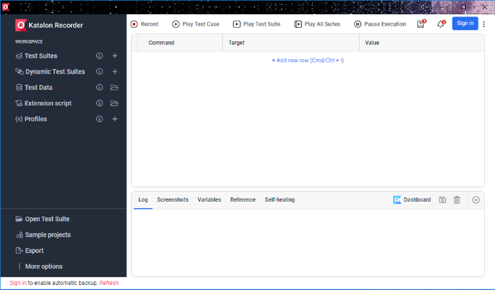Select **Katalon Recorder** and Install into Chrome. You may need to restart Chrome.
4. At the top right there is a Red Icon which is a shortcut to the recorder. If the icon is not there, check under the plugin icon . When you open the application, you should see a screen similar to the one to the right.

Firefox

1. Access the Add-ons menu option from the Firefox context menu (three lines in top right corner).
2. Search for "Katalon".
3. Select **Katalon Recorder** and Add/Install into Firefox.
4. You may need to restart Firefox.
5. At the top right you should notice a Red Icon  which is a shortcut to the recorder. When you open this you should see a screen similar to the one shown for Chrome